

Moon Landing

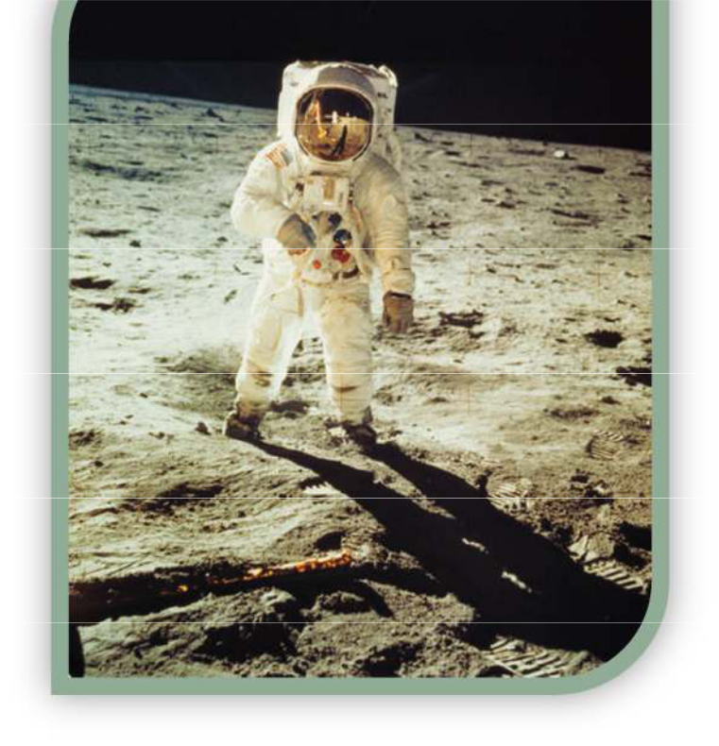

Moon Landing 1

Moon Landing

You are a member of a space crew scheduled to rendezvous with a mother ship on the lighted surface of the moon. However, due to mechanical difficulties, your own ship was forced to land at a spot 200 miles from the rendezvous point.

During re-entry and landing, much of the equipment aboard was damaged and, since survival depends on reaching the mother ship, the most critical items available must be chosen for the 200-mile trip.

15 items are listed as being intact and undamaged after landing. Your task is to rank them in terms of their importance for your crew, to allow them to reach the rendezvous point. Place the number 1 by the most important item, the number 2 by the second most important, and so on through to number 15 for the least important.

Instructions

- Provide a ‘moon landing ranking chart’ for every member of your group.

- Ask each young person to take 10 minutes to decide their own rankings, and record the choices in the left-hand column (my ranking).

- Invite everyone to get into groups of 3-4. Discuss their individual choices and refine their rankings based on the collective thoughts of the team. Record the group rankings in the second column (team rankings).

- The correct answers were compiled by a team of scientists and engineers at NASA. Display the NASA ‘expert’ rankings on a PowerPoint presentation, whiteboard or photocopy. Compare your individual and group answers with the correct answers and determine a score.

- For each item, mark the number of points that your score differs from the NASA ranking and then add up all the points. Disregard plus or minus differences. The lower the total, the better your score.

- As the young people work together in a team, sharing thoughts and ideas, this should produce an improved score over the individual results. But will this be enough to survive?


Moon Landing 2

Moon Landing Ranking Chart

My |  | Salvaged items |  | Team
ranking |  |  |  | ranking
 |  | Box of matches
 |  | Food concentrate
 |  | 50 feet of nylon rope
 |  | Parachute silk
 |  | Two .45 caliber pistols
 |  | One case of dehydrated milk
 |  | Two 100-pound tanks of oxygen
 |  | Stellar map
 |  | Self-inflating life raft
 |  | Magnetic compass
 |  | Five gallons of water
 |  | Signal flares
 |  | First aid kit containing injection needles
 |  | Solar powered FM receiver
 |  | Portable heating unit
Score |  |  |  | Score

Moon Landing 3

NASA Expert Analysis

 | Item |  |  | NASA |  |  | NASA's Reasoning
 | Item |  |  | Ranking |  |  | NASA's Reasoning
 | Box of matches |  | 15 |  |  |  | Virtually worthless -- there's no oxygen on the
 |  |  |  |  |  |  | moon to sustain combustion.
 | Food concentrate |  | 4 |  |  |  | Efficient means of supplying energy
 |  |  |  |  |  |  | requirements.
 | 50 feet of nylon rope |  | 6 |  |  |  | Useful in scaling cliffs and tying injured
 |  |  |  |  |  |  | together.
 | Parachute silk |  | 8 |  |  |  | Protection from the sun's rays.
 | Portable heating unit |  | 13 |  |  |  | Not needed unless on the dark side.
 | Two .45 caliber |  | 11 |  |  |  | Possible means of self-propulsion.
 | pistols
 | One case of |  | 12 |  |  |  | Bulkier duplication of food concentrate.
 | dehydrated milk
 |  |  |  |  |  |  | Most pressing survival need (weight is not a
 | Two 100 lb. tanks of |  | 1 |  |  |  | factor since gravity is one-sixth of the Earth's --
 | oxygen |  |  |  |  |  | each tank would weigh only about 17 lbs. on
 |  |  |  |  |  |  | the moon.)
 |  |  |  |  |  |  | Primary means of navigation - star patterns
 | Stellar map |  | 3 |  |  |  | appear essentially identical on the moon as on
 |  |  |  |  |  |  | Earth.
 | Self-inflating life raft |  | 9 |  |  |  | CO₂ bottle in military raft may be used for
 |  |  |  |  |  |  | propulsion.

Moon Landing 4

Magnetic compass | 14 | The magnetic field on the moon is not polarized,
Magnetic compass | 14 | so it's worthless for navigation.
5 gallons of water | 2 | Needed for replacement of tremendous liquid
5 gallons of water | 2 | loss on the light side.
Signal flares | 10 | Use as distress signal when the mother ship is
Signal flares | 10 | sighted.
First aid kit, including |  | Needles connected to vials of vitamins,
First aid kit, including | 7 | medicines, etc. will fit special aperture in NASA
injection needle | 7 | medicines, etc. will fit special aperture in NASA
injection needle |  | space suit.
Solar-powered FM |  | For communication with mother ship (but FM
Solar-powered FM | 5 | requires line-of-sight transmission and can only
receiver-transmitter | 5 | requires line-of-sight transmission and can only
receiver-transmitter |  | be used over short ranges.)

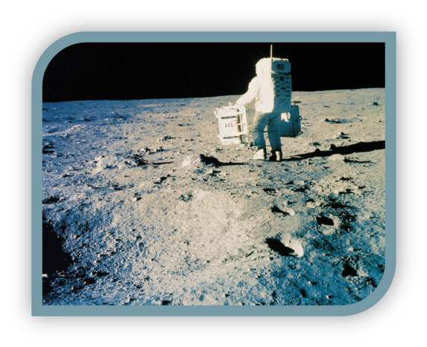

 |  |  |  |  |  |  | Moon Landing | 5
 | Scores
 | 00-25 |  |  | Excellent. |  |  | You and your crew demonstrate great survival skills!
 | 26-32 |  |  | Good. |  |  | Above average results. Yes, you made it!
 | 33-45 |  |  | Average. |  |  | It was a struggle, but you made it in the end!
 | 46-55 |  |  | Fair. |  |  | At least you’re still alive, but only just!
 | 56-70 |  |  | Poor. |  |  | Sadly not everyone made it back to the mother ship!
 | 71 + |  |  | Very poor |  |  | Oh dear, your bodies lie lifeless on the surface of the
 | 71 + |  |  | Very poor |  |  | moon!

